**Aim**

To implement a stack data structure using an array in C, and perform basic operations like **push**, **pop**, and **display**.

**Algorithm**

**1. Initialize:**

* Define an array to hold the stack elements.
* Define an integer top initialized to -1 indicating the stack is empty.

**2. Push Operation:**

* Check if the stack is full (top == max_size - 1), if yes, overflow occurs.
* Otherwise, increment top and insert the element at stack[top].

**3. Pop Operation:**

* Check if the stack is empty (top == -1), if yes, underflow occurs.
* Otherwise, return the element at stack[top] and decrement top.

**4. Display Operation:**

* If stack is empty, print "Stack is empty".
* Else, print elements from top to 0.

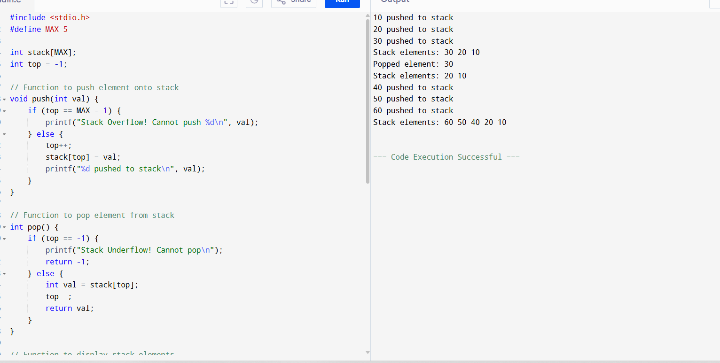

**Sample Output**

10 pushed to stack

20 pushed to stack

30 pushed to stack

Stack elements: 30 20 10

Popped element: 30

Stack elements: 20 10

40 pushed to stack

50 pushed to stack

Stack Overflow! Cannot push 60

Stack elements: 50 40 20 10